**RAID configuration and different types of RAID**

Janki Trivedi(121018)

**RAID**  **Redundant Array of Independent Disks**  is a data [storage virtualization](http://en.wikipedia.org/wiki/Storage_virtualization) technology that combines multiple [disk drive](http://en.wikipedia.org/wiki/Disk_drive) components into a logical unit for the purposes of data redundancy or performance improvement.

Data is distributed across the drives in one of several ways, referred to as [RAID levels](http://en.wikipedia.org/wiki/Standard_RAID_levels), depending on the specific level of [redundancy](http://en.wikipedia.org/wiki/Redundancy_(engineering)) and performance required. The different schemes or architectures are named by the word RAID followed by a number (e.g. RAID 0, RAID 1). Each scheme provides a different balance between the key goals: [reliability](http://en.wikipedia.org/wiki/Reliability_engineering),[availability](http://en.wikipedia.org/wiki/Availability), [performance](http://en.wikipedia.org/wiki/Computer_performance), and [capacity](http://en.wikipedia.org/wiki/Computer_data_storage#Capacity). RAID levels greater than RAID 0 provide protection against unrecoverable (sector) read errors, as well as whole disk failure.

On most situations you will be using one of the following four levels of RAIDs.

* RAID 0
* RAID 1
* RAID 5
* RAID 10 (also known as RAID 1+0)

In all the diagrams mentioned below:

* A, B, C, D, E and F – represents blocks
* p1, p2, and p3 – represents parity

RAID LEVEL 0

Following are the key points to remember for RAID level 0.

* Minimum 2 disks.
* Excellent performance ( as blocks are striped ).
* No redundancy ( no mirror, no parity ).
* Don’t use this for any critical system.

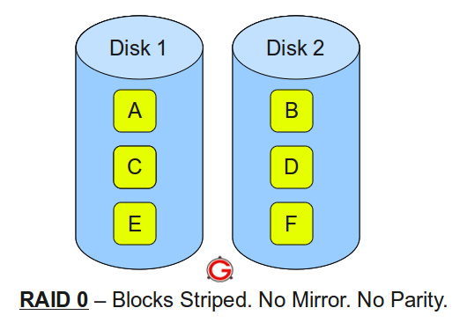

### RAID LEVEL 1

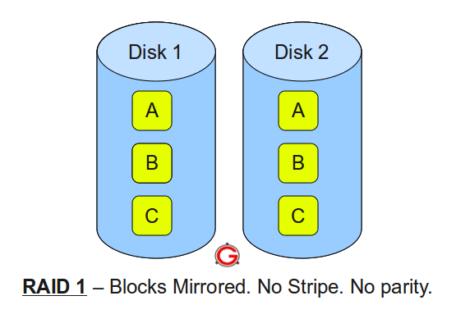

Following are the key points to remember for RAID level 1.

* Minimum 2 disks.
* Good performance ( no striping. no parity ).
* Excellent redundancy ( as blocks are mirrored ).

### RAID LEVEL 5

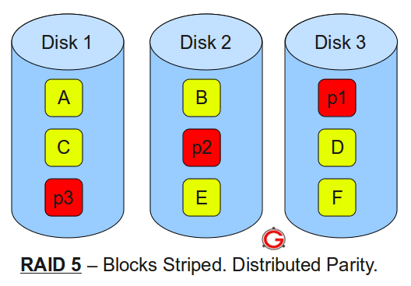

* Minimum 3 disks.
* Good performance ( as blocks are striped ).
* Good redundancy ( distributed parity ).
* Best cost effective option providing both performance and redundancy. Use this for DB that is heavily read oriented. Write operations will be slow.

### RAID LEVEL 10

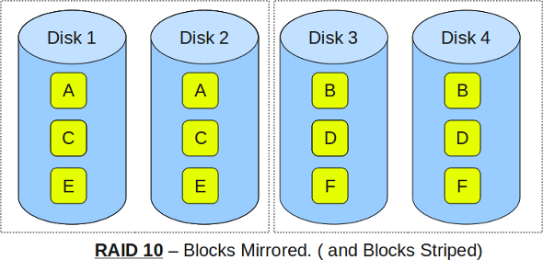

* Minimum 4 disks.
* This is also called as “stripe of mirrors”
* Excellent redundancy ( as blocks are mirrored )
* Excellent performance ( as blocks are striped )

**Different types of RAID:**

**Software RAID:**

In this case, the RAID implementation is an application running on the host without any additional hardware. This type of software RAID uses hard disk drives which are attached to the computer system via a built-in I/O interface or a processor-less host bus adapter (HBA). The RAID becomes active as soon as the operating system has loaded the RAID driver software. Such pure software RAID solutions often come integrated into the server OS and usually are free of additional cost for the user. Low cost is the primary advantage of this solution.

**Hardware RAID:**

A hardware RAID solution has its own processor and memory to run the RAID application. In this implementation, the RAID system is an independent small computer system dedicated to the RAID application, offloading this task from the host system. Hardware RAID can be found as an integral part of the solution (e.g. integrated in the motherboard) or as an add-in card.

If the necessary hardware is already integrated in the system solution, then hardware RAID might become a software upgrade to your existing system. So like software RAID, hardware RAID might not be identified as such at first glance

**Fake RAID:**

Fake RAID is essentially software RAID provided by the BIOS on the motherboard, however, it has none of the benefits of Software RAID and none of the benefits of Hardware RAID, hence, Fake RAID.

Unlike Hardware RAID, Fake RAID does not present the array as a single logical disk to the OS, so the OS still needs to explicitly support Fake RAID. Unlike Software RAID, Fake RAID does not use a consistent on disk format, and if your motherboard dies, your data is probably lost unless you can find another identical motherboard. So, with Fake RAID:

* Use RAID 0 or 1.
* Can't nest RAID arrays.
* Create RAID arrays using whole disks only.
* Pray your motherboard never dies or keep several identical ones on hand.
* Can't have hot spares and can't support hot swappable drives.

**References:**

* <http://skrypuch.com/raid/>
* <https://www.adaptec.com/nr/rdonlyres/14b2fd84-f7a0-4ac5-a07a-214123ea3dd6/0/4423_sw_hwraid_10.pdf>
* <http://en.wikipedia.org/wiki/RAID>
* <http://www.thegeekstuff.com/2010/08/raid-levels-tutorial/>
* <http://www.prepressure.com/library/technology/raid>